Table of Contents

1. Game Overview

* Introduction
  + Our game is set in a post apocalyptic earth, overrun with mutated species. The player goes through the world while killing, looting and shooting through hordes of enemies. Kill or be killed is the only rule for survival.
* Story Synopsis
  + In the 21st century, Some space ray hit earth and shattered the planet. The “Uniques’ appeared from the mutation and terrorised earth. The “Agency” was created with the union of all countries hiring specialized soldiers to fight back against the “Uniques”.
* Target Audience
  + Male, 15-35
  + Action, FPS, Adventure, Open-world
* Target Platform
  + Hardware: Console & PC
  + Platform: Steam, Epic, Itch.io, Game Jolt
* Visual style
  + Realistic open world with dynamic day/night/weather cycle, which allows players to experience a wide range of elements, making them more immersed in the game
* Fog of war, to cover up far rendered (compressed) textures
* Muted almost monotone colors which provides that post apocalyptic feel, but with enough details for realism.
* Unique selling point

1. Gameplay

* Objective
  + To explore the new apocalyptic land
  + Fight mobs
  + Accomplish missions
  + Level up and loot better gear
  + Fight Bosses
* Core Mechanics **(refer to Interactions)**
* Actions **(refer to Interactions)**
* Interactive Objects **(refer to Objects)**
* Combat **(refer to Guns & Attachments and Weapons & Attacks)**
* Artificial Intelligence
  + 3 NPCs
  + 5 Mobs(take from below)
  + 2 Boss
* Economy
  + Monster Parts, loot drop from bosses
  + Equipment for multiplayer trading
  + Cold Hard Cash, awarded for doing quests

1. Universe(World Building)

* Story
  + Stuff, copy from previous doc and edit, background, plot, game progression **based on gameplay mechanics**
* Characters //do not include mechanics of character
  + Main character
  + Scientist
  + Person behind the dialogue
  + Vendor, shop person
* Levels/Maps
  + Urban city area(Zombies)
  + Rural(Goblins)
  + forested(Wolves)
  + snowy(Yeti)
  + mountainous(Massive Birds)
  + Underground Caverns(Slime)
  + Wonstin’s Science facility area, with harder monsters but better loot rewards, and requires an expensive and rare keycard to enter(Infected Robots and All of the Above Bosses)

1. Control & Interface

* Camera(First person)
  + FOV of 100 degrees(for calculations)
* Control Interface(reference image to keyboard control scheme and key binds)
  + WASD for player movement control relative to position and mouse direction
  + QEF for skills
  + 1234567890 for quick slots (Hotbar)
  + R for reload
  + Space for jump
  + Shift for crouch/sneak
  + Ctrl for sprint
  + Tab for map
  + ZXCVB for others
  + LMB for shoot
  + RMB for ADS
  + Scroll wheel for weapon change
  + Mouse movement for aiming
* Heads Up Display(HUD)
* Screenflow(flowchart)

1. Audio, Music & Sound effects

* Just list a bunch of stuff

1. Appendix

* Research links and sources
* Reference games
  + Currently, has Subnautica, Warframe, Destiny, Escape from Tarkov, Unturned, Monster Hunter Franchise, Dauntless

1. Others

* Stuff

Core Game Flow, Session Length

Base Flow(only in base)

* Get mission from general
* Mod weapons for combat
* Gear up at armoury with guns and armor
* Get consumables and stuff
* Garage to leave for battle
* Return from battle
* Report to general for mission reward
* Sell and buy items at vendor/ currency based stuff
* repeat

--------------------------------------------------------------------------------------------------------------------------------------------

Task Flow/Design History:

22/12/2021; jerryl: skills(combat and survival)

22/12/2021: winston: added header structure, referral guides and slight annotations, added movement, inventory, weapons, consumables, ammunition, attachments, skills, status effects, core interactions, secondary interactions

23/12/2021: winston: basically expanded on everything i did yest, added Guns & Attachments and Weapons & Attacks, basic GDD flow and structure

24/12/2021: winston: added more to GDD flow and added Consumables, Interactions and references. Added Objects. Followed jerryl’s example and added clarity to everything

winston+Jerryl: Movement, added clarity to entities, skills and consumables and a few others

28/12/2021: winston: expanded on Bows and Arrows, values:defence and projectile damage, Inventory:Slot Size

31/12/2021: winston: added reference images for inventory, world map, gun modding, all made games

01/01/2022: Koh Win: expanded on the guns list. Added the FN-Five Seven, MP5,Ak-74, M4A1, Lapua Magnum, DVL-10, Saiga-12 and Mossberg. Added attachments to the bows and added corresponding ammo variants.

Jerryl: expanded on Revolver, Glock, Fn five seven, Uzi, Added weapon damage fluctuations to melee

02/01/2022: winston: enemy rework, AI for NPC and other story characters, base objects, cosmetics

Jerryl: added stocks, foregrips, some sights, added gun reference images

Koh Win: Expanded details about damage, accuracy etc on the rest of the guns.

03/01/2022: Koh Win: Changed how the accuracy system, MOA and stamina system works. Added on to how the weight system works. Added details to how the extraction and server system will work.

10/01/2022: Koh Win: Added Perma death, map, server picking, and Insurance details

Plan: add all reference images and notes after 50% completion, then ask for consultation and start the document with lecturer’s reply and evaluation. Start slides after GDD 25% completion. Port over more things and work alongside GDD. start script

--------------------------------------------------------------------------------------------------------------------------------------------

Description of Gameplay: The PVE aspect of the game would be a group of players would try and defeat a high health boss, with waves of minions with the difficulty aspect of dark souls which will thus need to create a new strategy for each boss and zone environment. The customization or upgrade aspect of the game would be the guns which some would be futuristic or modern or having a fusion between the two, alongside progressively improving equipment and leveling skill trees.

--------------------------------------------------------------------------------------------------------------------------------------------

Playing Area is 1000m by 1000m by 1000m(x,y,z respectively)

Player specific stats:

What exists for character

Camera is pointing from perspective of HEAD, permanent aiming FOV of 100 degrees, separate from graphical FOV, which the player can change

* Base Stats levels exist, check below put in table
  + Dimensions: 0.5x2x0.5m xyz
  + Affected by gravity, falls at 10m/s^2
  + 100hp, 10 defence
  + 100KG weight, affects fall rate and stuff
  + 50kg carry cap
  + No base resistance to any status effects
  + Passive regeneration of 1%/5s
* Movement
  + Player walks at a speed of 1.5 m/s, moves same speed in all directions
  + Player can only sprint forward at 2.5m/s
  + Player crouches to a height of 1m, lowering hitbox but does not change other dimensions (changes only y axis), moves at 0.5 m/s
  + Player Jumps 1m high, for 1s
  + Player can Dodge roll with i-frames for 0.5s, over a distance of 1m, for all 4 directions
  + ADS prevents sprinting and rolls, only walking
* Player Lore/Desc: what was shown in first playthrough cut scene
  + Average Joe that was conscripted in the army. Left the warzone to settle down. Asteroid hit and an apocalypse happened, family died, grief and anger. Called back into duty, then “tutorial stage”, shown remarkable skill, requested to be in special forces. End scene with application and badge stamped with “Approved”
  + Likes Guns and explosions, the bigger the better
  + Wants to kill more bosses and enemies in revenge for family
* Stuff

Enemies:

* Type Minion A(Goblin): solo mob
  + Dimensions:1x1x1m xyz
  + Patrol speed: 1m/s
  + Speed when player is spotted: 1.5m/s
  + Jumps 1m high, for 1s, falls w gravity of 10m/s
  + Stops immediately when about to attack, no movement during attack
  + Charges for 0.5s, attacks for 0.3s, recovers for 0.4s
  + Attacks only when player is within 1m
  + Detection range of 30m
  + Desc: simple goblin, no one knows where it comes from, weak and feeble with intelligence of 3 year old
* Type Minion B(Wolf): herb mob
  + Dimensions:1x1x2m xyz
  + Patrol Speed is 1m/s
  + Speed when Player is spotted is 3m/s
  + Does not Jump, but can lunge
  + Lunges forwards over 2m, over 0.5s, every 3s when in range of 2m from player(Reference image needed, each frame thing )
  + Falls with gravity of 10m/s^2
  + Detection range of 30m
  + Upon detection of player, “Howls” for 3s, alerting all pack mates within 10m radius
  + Mutated wolves that grew stronger from the asteroid, sticks in a pack. Easy to deal with individually, but a pain when 3 or more appears together
* Type Minion C(Fire Spirit): ranged mob
  + Dimensions:0.5x0.5x0.5m xyz
  + Patrol Speed is 0.5m/s
  + Speed when Player is spotted is 1m/s
  + Is not affected by gravity
  + Detection range of 30m
  + Attacks with ranged capabilities
  + 5m range, attacks every 1s for 10dmg, onto player’s current position
  + 10% chance to apply “Burning” effect**(refer to Status Effects:Combat:Burning)** for 5s
  + Literal fire given form, weak body but burns brightly at night. Be careful of its fiery spit
* Type Minion D(Ice Yeti): tanky mob
  + Dimensions:2x4x2m xyz
  + Patrol Speed is 1m/s
  + Speed when Player is spotted is 3m/s
  + Falls with gravity of 10m/s^2
  + Detection range of 10m
  + Applies “Cold”**(refer to Status Effects:Survival:Cold)** effect within 10m radius on player
  + Melee Attacks when player is in within 2m, for 20dmg
  + Charges for 1s, attacks for 0.5s, recovers for 1.5s
  + The Abominable snowman was not just a legend, thick hide and a thicker skull, nearly impossible to see when its white fur blends in with the blizzard. It carries the blizzard with it.
* Type Boss B(Alpha Wolf):
  + Dimensions: 5x5x10m xyz
  + Does not Patrol, stationary until Combat
  + Moves at 5m/s, in 4 directions
  + COMBAT:
    - Howls every 1 min to summon 5 wolves
    - Lunges forwards over 5m, over 1s dealing 20dmg
    - Sand Attack, throws sand in direction of player with angle of 20 degrees, range of 10m, reduces player’s view range to 2m(similar to fog of war, but yellow and particles)

--------------------------------------------------------------------------------------------------------------------------------------------

How values are calculated:

* Defence: 2 defence is 1% less damage taken from physical sources
  + Low defence is below 30, medium(armored) is between 30 and 80, and high defence is above 80
  + Which scales to 15%, 40% and above

//no resistance to bleeding

* Melee Damage = Strength(after adjustment)*Weapon Modifier*Attack Combo Phase(include fluctuation)*defence reduction
* Resistance to effects = (Specific Resistance(after adjustment)^0.5)*effect of status effect
  + ^0.5 should make a diminishing effect, help fix
* Projectile damage: (Weapon Damage*Ammunition Damage(against different enemies)*range drop off)*defence reduction
  + Range Drop Off: impact within effective range deals 100% damage, as a multiplier of (effective range/5)//impact distance*100%,
  + ie effective range of 100, impact distance of 150
  + Range drop off is 100/5/150*100 = 20/150*100% = 13%
* Headshots deal 2x damage, but equipment can reduce damage to head further
* Stuff
* Accuracy: Accuracy is calculated in % of MOA, which is a measurement of how far the bullets will spread from one another. We capped this at a set 100 degrees of FOV for simplicity. For example, 100% MOA means the bullets will hit with 0 cm of spread, whereas 50% MOA means that the bullet has a random chance of hitting anywhere within 50% of that 100 degree FOV. 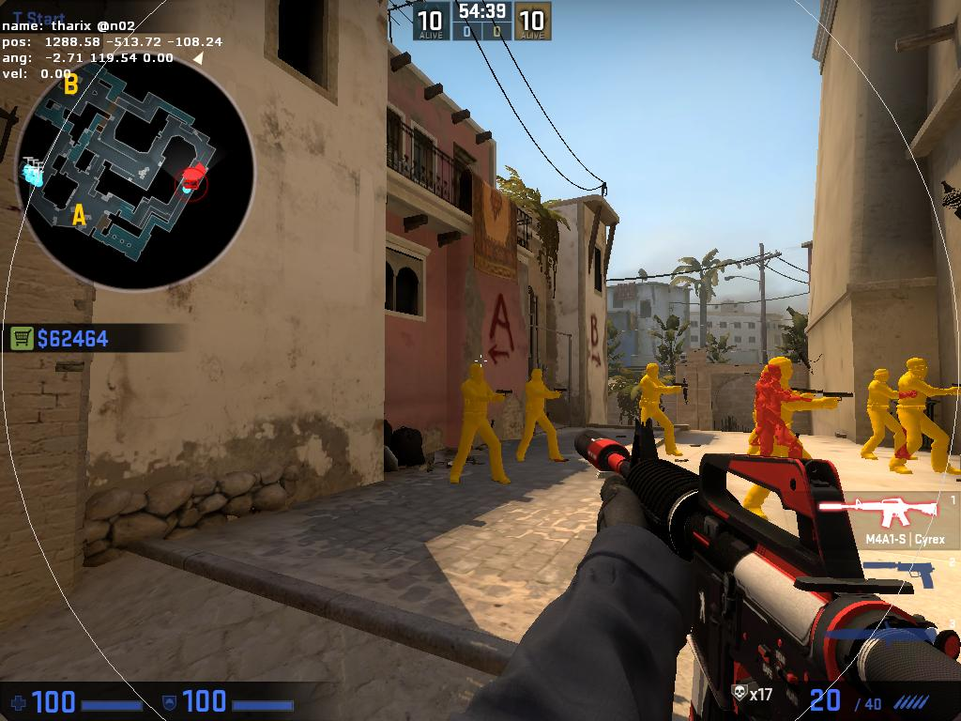game: csgo. The circle represents the set FOV, which differs from camera FOV. Obviously the circle size was exaggerated for show. 50% means it will be hitting anywhere within 50% of that circle size.

“After adjustment” refers to all skill trees, equipment, attachments and consumables.

--------------------------------------------------------------------------------------------------------------------------------------------

Guns & Attachments

//what are guns in this game (equipable items?, how many guns are equipable?)

* Guns

1. Pistol (SemiAuto)
   1. Revolver
      1. Weight: 1kg
      2. Slot Size: 2x2
      3. Ammo types: Hollow point, glow
      4. Ammo capacity: 24
      5. Fire rate: 0.8s
      6. Accuracy: 100% on ads, 80% hip fire,
      7. 90% ads n move, 50% when hipfire n moving
      8. Effective range: 30m
      9. Damage: 25 * ammo multiplier
   2. Deagle
      1. Weight: 1kg
      2. Slot Size: 3x2
      3. Ammo types: armor piercing, FMJ
      4. Ammo capacity: 7
      5. Fire rate:1.2s
      6. Accuracy: 100% on ads, 80% hipfire
      7. 90% ads n move, 60% when hipfire n moving
      8. Effective range: 100m
      9. Damage: 35 * ammo multiplier
   3. Glock 17
      1. Weight: 1kg
      2. Slot Size: 2x2
      3. Ammo types: hollow point, glow
      4. Ammo capacity: 17
      5. Fire rate: 0.3s
      6. Accuracy: 100% ads, 75% hipfire
      7. 60% when moving n hipfire, 90% ads n move
      8. Effective range: 50m
      9. Damage: 20 * ammo multiplier
   4. FN-five-seven
      1. Weight: 1kg
      2. Slot Size: 2x2
      3. Ammo types: hollow point, glow, armor piercing
      4. Ammo capacity: 20
      5. Fire rate: 0.4s
      6. Accuracy: 100% ads, 75% hipfire
      7. 60% when moving n hipfire, 90% ads n move
      8. Effective range: 70m
      9. Damage: 20 * ammo multiplier
2. SMG (Auto)
   1. Uzi
      1. Weight: 2.5kg
      2. Slot Size: 2x2
      3. Ammo types: hollow point, glow
      4. Ammo capacity: 32
      5. Fire rate: 0.1s
      6. Accuracy: 100% ads, 80% hipfire
      7. 95% ads moving, 70% when moving n hipfire
      8. Effective range: 40m
      9. Damage: 25 * ammo multiplier
   2. Vector
      1. Weight: 2.5kg
      2. Slot Size: 3x2
      3. Ammo types: Hollow point, glow
      4. Ammo capacity: 33
      5. Fire rate: 0.075s
      6. Accuracy: 95% ads, 75% when moving n hipfire
      7. Effective range: 20m
      8. Damage: 20 * ammo multiplier
   3. P90
      1. Weight: 4kg
      2. Slot size: 3x3
      3. Ammo types: Hollow point, glow, AP
      4. Ammo capacity: 50
      5. Fire rate: 0.09s
      6. Accuracy: 90% ads, 80% when moving n hipfire
      7. Effective range: 50m
      8. Damage: 15 * ammo multiplier
   4. Mp5
      1. Weight: 2.5kg
      2. Slot size: 2x3
      3. Ammo types: Hollow point, glow,
      4. Ammo capacity: 30
      5. Fire rate: 0.15s
      6. Accuracy: 100% ads, 90% when moving n hipfire
      7. Eff range: 100m
      8. Damage: 20 * AM
3. Assault Rifle
   1. Famas
      1. Weight: 4kg
      2. Slot size: 3x4
      3. Ammo types: FMJ, Composite,
      4. Ammo Cap: 30
      5. Fire rate: 0.075s for 3 rounds then 1s cooldown, or 0.05s per bullet
      6. Has burst or auto.
      7. Accuracy: 90% ads, 50% when moving n hipfire
      8. Damage: 20 * AM
   2. Scar
      1. Weight: 4.5kg
      2. Slot size: 3x5
      3. Ammo types: AP, FMJ, Composite, Incendiary, HE
      4. Ammo Cap: 20
      5. Fire rate: 0.35s
      6. Accuracy:100% ads, 40% when moving n hipfire
      7. Damage: 40 * AM
   3. Ak-74
      1. Weight 3kg
      2. Slot size: 3x4
      3. Ammo types: FMJ, Composite, AP
      4. Ammo Cap: 30
      5. Fire rate: 0.15s
      6. Accuracy:85% ads, 30% when moving n hipfire
      7. Damage: 28 * AM
   4. M4a1
      1. Weight 5kg
      2. Slot size: 4x4
      3. Ammo types: FMJ, Composite, AP, Incendiary
      4. Ammo Cap: 30
      5. Fire rate: 0.1s
      6. Accuracy:95% ads, 50% when moving n hipfire
      7. Damage: 25 * AM
4. Sniper Rifle
   1. Barrette .50 cal
      1. Weight 10kg
      2. Slot size 4x6
      3. Ammo types: FMJ, AP, HE
      4. Ammo Cap: 5
      5. Fire rate: Bolt action 2s
      6. Accuracy: 100% ads, 20% when moving
      7. Damage: 120 * AM
      8. Reload speed: 5s
   2. Lapua Magnum
      1. Weight 8kg
      2. Slot size 5x6
      3. Ammo types: FMJ, AP, incendiary
      4. Ammo Cap: 10
      5. Fire rate: 0.5s Semi auto
      6. Accuracy: 95% ads, 10% when moving
      7. Damage: 70 * AM
      8. Reload speed: 6.5s
   3. Remington M700
      1. Weight 5kg
      2. Slot size: 3x4
      3. Ammo Cap: 10
      4. Ammo types: FMJ, AP
      5. Fire rate: 2s Bolt action
      6. Damage: 60 * AM
      7. Accuracy: 100% ads, 10% when moving
      8. Reload speed: 4.2s
   4. DVL-10 saboteur
      1. Weight 9kg
      2. Slot size: 4x5
      3. Ammo Cap: 10
      4. Ammo types: FMJ, AP
      5. Fire rate: 2s bolt action
      6. Damage: 75 * AM
      7. Accuracy: 100% ads, 25% when moving
      8. Automatically Silenced
      9. Reload speed: 4s
5. Shotty
   1. Benelli
      1. Weight 5kg
      2. Slot size: 3x3
      3. Ammo Cap: 5
      4. Ammo types: Slugs, Buckshot
      5. Fire rate: 0.5s
      6. Damage: 10 * buckshot
      7. Accuracy: 70% ads, 60% when moving
      8. Reload speed: 0.5s per ammo, can be cancelled any time
   2. Double barrel
      1. Weight 3kg
      2. Ammo Cap: 2
      3. Ammo types: Slugs, Buckshot
      4. Slot size: 2x4
      5. Fire rate: 0.2s
      6. Damage: 15 * buckshot
      7. Accuracy: 60% ads, 50% when moving
      8. Reload speed: 4s
   3. Remington
      1. Weight 3.9kg
      2. Ammo cap: 6
      3. Slot size: 3x4
      4. Fire rate: Pump action 1s
      5. Damage: 12 * buckshot
      6. Accuracy: 75% ads, 60% when moving
      7. Reload speed: 0.6s per ammo, can be cancelled any time.
   4. Saiga-12
      1. Weight: 5.5kg
      2. Ammo Cap: 10
      3. Slot size: 5x4
      4. Fire rate: 0.3s semi auto
      5. Damage: 20 * buckshot
      6. Accuracy: 70% ads, 40% when moving
      7. Reload speed: 3s

* Gun Attachments

1. Stocks
   1. Grip Stock
      1. Increases Recoil Control by X (need discussing)
   2. Comb Stock
      1. Increases Recoil Control by X
2. Foregrips
   1. Vertical Grip
      1. Increases Recoil Control by X
   2. Angle Grip
      1. Increases Recoil Control by X
   3. Short Angled Grip
      1. Increases Recoil Control by X
3. Sights
   1. Iron sights, default scope attached to gun
      1. No buffs
   2. Red dot, Holographic projection of a red dot in place of scope
      1. Changes ads reticle to small red dot
      2. Increases ads accuracy by x
   3. Night vision, military scope that provides simple night vision capabilities
      1. Has a green tint and increases brightness within scope
      2. No increase of accuracy, just visual
   4. 2x scope, simple scope attached by bolts
      1. Scopes with 2x magnification, not adjustable
      2. Increases ads accuracy by x
   5. 4x scope, Strong scope attached by bolts
      1. Scopes with 4x magnification, not adjustable
      2. Increases ads accuracy by x
   6. Sniper Scope(toggled scope), issued Sniper scope allows for variable zooming in
      1. 1x,2x,4x variable scope
      2. Increases ads accuracy by x
      3. Available on <Snipers only>
4. Barrels
   1. Silencer (Combined with flash suppressor)
      1. Reduces effective range by 10m
      2. Reduces sound produced by gun by 75%
      3. Eliminates muzzle flash from enemy sight
      4. Only Available on <pistol name>,<rifle name>,<sniper name>
5. Utilities
   1. Bayonette**(refer to Weapons & Attachments:4)**
      1. Available on <rifle name>,<shotgun name>
   2. Recon
      1. Flashlight, lights up area in front of player with angle of 15 degrees, 5m range
         1. Available on x
      2. Laser, shines a colored laser to highlight where the bullet will hit
         1. Increases hip fire accuracy by x
6. etc

* Bows(silent)

1. Compound Bow
   1. Weight of 5kg
   2. Takes 2x5 slots
   3. Uses arrows, broadheads and tipped arrows
   4. Holds 1 arrow, draw time is 2s(reload time is draw time)
   5. Percentile drawing reduces power equivalent to time left to full draw
   6. Cancelling attack will return arrow to quiver
   7. Effective range is 50m
   8. Full draw deals 50 damage
   9. Adds a slight tremor effect that decreases accuracy. Bow moves back and forth rapidly over a very short distance.
2. Crossbow
   1. Weight of 10kg
   2. Takes 2x5 slots
   3. Uses bolts and tipped bolts
   4. Holds 1 bolt, reloads for 4s
   5. Ready to fire on click
   6. Deals 100 damage
   7. Effective range is 100m
   8. Travels at a speed of 100mph
3. Repeating Crossbow
   1. Weight of 3kg
   2. Takes 1x3 slots
   3. Uses bolts and tipped bolts
   4. Holds 8 bolts, reloads for 3s(just remove old magazine and attach new one)
   5. Ready to fire on click
   6. Fire interval of 0.5s per bolt
   7. Deals 15 damage
   8. Effective range 25m

* Compound Bow Attachments

1. Makeshift Scope
2. Allows for further zooming (2x) other than using iron sights (1x).
3. Adds a wooden stick as a reticle

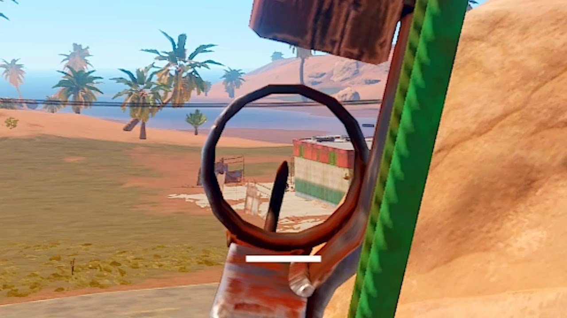game: rust

1. Increases accuracy by 5%

Desc: A makeshift scope you made using metal scraps, wood, and a lot of glue.

2. taut ropes.

a. Increases bold holding by 0.2s

b . Increases speed of arrow by 50kph

c. Effective range increased to 150m

d. Increases Tremor effect.

Desc. Tighter ropes make arrows fly faster, further. Requires more strength to pull back.

3. Padded grip.

a. Decreases Tremor effect significantly.

b. Increases bold holding by 0.1s

Desc: Padded grips offer easier and more comfortable handling.

4. Makeshift Flashlight.

a. Increases accuracy by 5%

b. Adds a Flashlight for the ability to see in the dark.

Desc: a flashlight precariously mounted onto the top of the bow with some loose bolts

* Crossbow Attachments

1. Improved Iron sights
2. Increases scope to 2x from 1x.

Desc: a better scope to see from.

1. Monstrum 2-4x Scope
2. Increases scope to a togglable 2x or 4x from 1x.
3. Increases accuracy by 5%
4. Adds a reticle that will be shown when ADS

Desc: A medium range scope developed by Monstrum industries.

3. Padded grip.

1. Decreases Tremor effect significantly.
2. Increases bold holding by 0.1s

Desc: Padded grips offer easier and more comfortable handling.

4. Taut ropes.

a . Increases speed of arrow by 50kph

b. Effective range increased to 150m

c. Increased reload time by 0.25s

Desc. Tighter ropes make arrows fly faster, further. Requires more strength to pull back.

5. Makeshift Flashlight.

a. Increases accuracy by 5%

b. Adds a Flashlight for the ability to see in the dark.

Desc: a flashlight precariously mounted onto the top of the bow with some loose bolts

* Repeating Crossbow Attachments

1. Makeshift Scope
2. Allows for further zooming (2x) other than using iron sights (1x).
3. Adds a wooden stick as a reticle
4. Increases accuracy by 5%

Desc: A makeshift scope you made using metal scraps, wood, and a lot of glue.

2. Double Strings

a. Increases rate of fire from 0.5s to 0.25s.

b. Decrease accuracy by 15%

Desc: Double the strings allows for twice the fire rate, but way less accurate.

4. taut ropes.

a . Increases speed of arrow by 50kph

b. Effective range increased to 150m

c. Increases Reload time by 0.25s

Desc. Tighter ropes make arrows fly faster, further. Requires more strength to pull back.

5. Makeshift Flashlight.

a. Increases accuracy by 5%

b. Adds a Flashlight for the ability to see in the dark.

Desc: a flashlight precariously mounted onto the top of the bow with some loose bolts

Weapons & Attacks

* Each Weapon has its own attack Combo, looping across after every cycle
* All weapons have the same range(not realistic but idc) of 1m in front of the player
* Melee Attacks only work when melee weapon/attachment is within inventory, if more than 1 weapon, use quick slot first, or until user chooses otherwise
* Weapons

1. Bowie Knife(medium speed, medium damage), has 2 attack chain before 1 heavy (fluctuation of actual dmg ranges from 90-110%, 90-110%, 110-120%)

* Slot size of 1x3, weight of 1kg
  1. Attack 1
     1. Swing Diagonally top right to bottom left
     2. Charge for 0.3s, attack for 0.4s
  2. Attack 2
     1. Swing horizontally from left to right
     2. Attack for 0.4s
  3. Recover, affects both previous attacks
     1. Such as only the first attack goes, player needs to recover
     2. But if the player chains with 2nd attack, only the second attack needs to recover before going for the 3rd attack
     3. 0.5s
  4. Finisher
     1. Thrust forwards with 2 hands
     2. Charge for 0.6s, attack for 0.5s, recover for 1s

1. Fire Axe(slow speed, high damage) 2 phases (fluctuation of actual dmg ranges from 110-120%)

* Slot size of 2x4, weight of 3kg
  1. Attack 1
     1. Swing horizontally with 2x damage
     2. Charges for 1s, swings for 0.5s, recover for 0.5s
  2. Finisher
     1. Attacks downwards with 5x damage
     2. Charges for 2s, swings for 0.5s, recover for 2s

1. Bayonette(rifle/shotgun attachment. 1 attack phase only, gun with attachment in inventy, no need for separate weapon) stabbing motion (fluctuation of actual dmg ranges from 90-110%, 90-110%, 110-120% )
   1. 1 attack phase(stabbing motion forwards like spear)
   2. Charge for 0.3s, attack for 0.2s, recover for 0.3s.
      1. Attack modifier of 1.2x
2. Riot Shield(left arm, can only equip small arms, ie pistols/smg, or consumables or melee)
   1. Increases defence by 50% of base defence when equipped
   2. Durability of 150 ie. takes 150 damage before unusable
   3. Shield bash(active ability)
      1. Charge for 0.5s, attack for0.5s, recover for 1s.
      2. Active ability Cooldown for 5s
      3. Bash does 0.5x damage, but knocks back target for 3m

--------------------------------------------------------------------------------------------------------------------------------------------GAME LOGIC vvv

Inventory

Inventory can only be designated in base as a preparatory stage, where players can plan out their gear to tackle certain environments and enemies

* Slots/Capacity
  + Each Backpack has a certain number of slots, players need to arrange their Inventory, where each item has a grid based slot size of Varying Complexities
  + //refer to subnautica and unturned and kenshi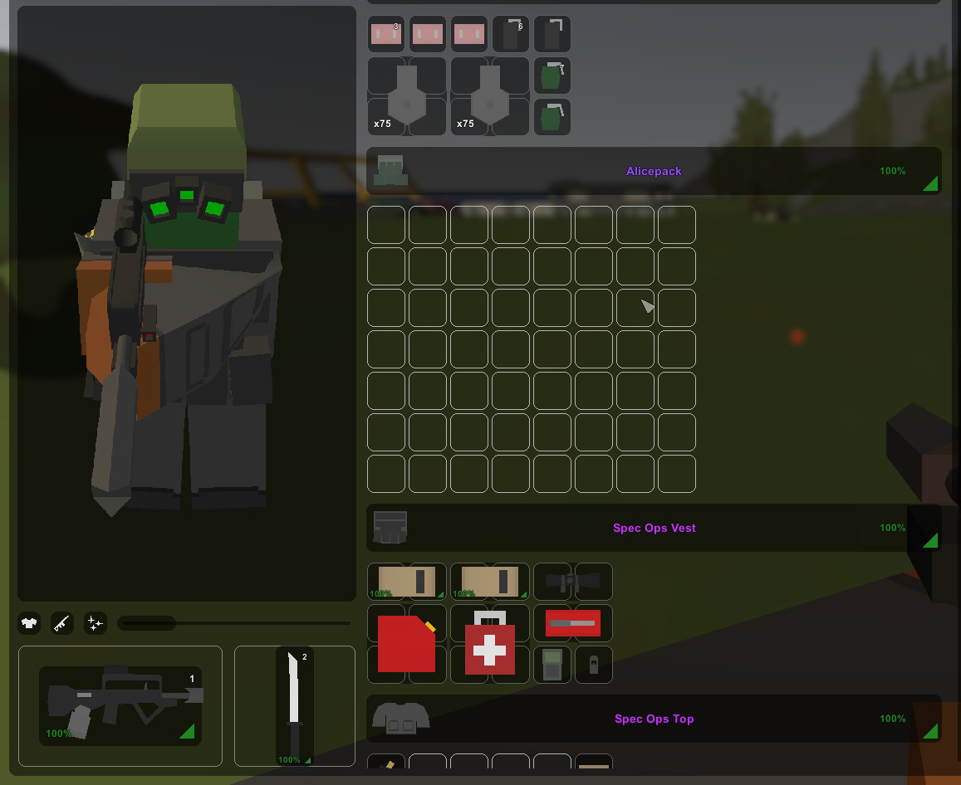game: unturned
  + **(refer to Categories:Equipment)** Players can freely choose their armor and backpacks, changing the number of slots within their bag, such as vests or grenadiers belts, increasing their quick access slots. Or to reduce capacity by focusing on defense, such has bullet proof vests //refer to unturned
  + When referring to slot size, ie x by y,
* Weight**(refer to Skills:Support:3)**
  + Each item has a base weight, with gun attachments being NULL weight(aka each gun with full attachments only counts as base weight). Players can only carry a limited weight each time when leaving base, this is to prevent over preparation.
  + Out of base, during the combat phase, players can loot new consumables and ammunition, where should they go over the limit, they would be fatigued and encumbered, slowing them down significantly and preventing maneuvers. //script
  + There are 3 phases to weight. Underweight, overweight, and severely overweight. In the Underweight stage, the player is free to add collectables and guns that increase weight without any consequences. If they carry over a certain weight limit, they will be put into the overweight stage, and will be granted a set of debuffs, ranging from significantly higher stamina consumption, to lower jump height and even running speed. The player can however, still collect items and move. If the player reaches the max weight limit, they will be put into the severely overweight stage. They will be granted the debuff “exhaustion” and will move at the slowest speed possible, and will be unable to jump or sprint. Players can no longer carry more items and will have to discard items to lower their weight.
  + Weight classes are as follows, anywhere from 0% to 90% of carrying capacity is underweight, 90% to 110% is overweight, and anything past 110% is considered severely overweight.
  + This also allows players to restock their supplies during a run, as well as poorer players to enter the battlefield underprepared, and loot their way through, increasing their equipment for the next run //script
  + But prevents over looting in 1 run, as opposed to multiple runs, encouraging breaks in between sessions. This makes the game seem less repetitive in 1 sitting as players would rest and do other things, and makes the loot more valuable.
* Quick access/hotbar
  + Quick access slots can be used with a click of a button, allowing players to circumvent going into the inventory to equip them
  + Players can designate items to be in Quick Access slots, in pockets during combat stages, such slots have limited space, such as only being able to hold X magazines, or X injections. Bulky items cannot be placed in Hotbar, ie medkits
  + However, players can use these quick access slots as inventory space during the planning stage. However, during combat, the player requires the “Out-Of-Combat” **(refer to Status Effects:Survival:Out-Of-Combat)** effect to be able to allocate more items into the quick access slots
  + How to assign quick access: step 1: move the item you want to use quickly to your pocket.
  + Next, hover over the item in the pocket and click a key from 4 to 0.. It will then be assigned into a hotbar. Numbers 1 to 3 are reserved for your primary, secondary and tertiary weapons.
* Stamina Bar
  + Stamina Bar grants players with a set amount of stamina. There are 2 phases to the stamina bar, green and red. If stamina is higher than 20 out of 100, the stamina is in the green. The player can:
    - Start running (10 stamina per second of running), Jump (15), Vault (10), Climb ladders(10 stamina per second of climbing), etc
  + If the Stamina Bar hits red, which is below 20, the player cannot:
    - Start running, jump.
    - Players can still Vault and climb ladders, but they will be slowed by 25%.
    - The player can start running in the green, and if the stamina hits red, they can continue to run, but will stop running when stamina hits 0. If they ever stop in the red, they cannot start running again until the stamina hits green.
  + Stamina will regenerate so long as the player is not doing anything that costs stamina for 2 seconds by 10 stamina per second
  + When you get shot or hit by a monster, you lose stamina, until you hit 20, where you can no longer lose stamina when you get shot. This is how we implement stopping power.
* How Servers will work
  + When you start a match, you are put into a queue with everyone else who is queueing. When enough players are found for a certain map, a server will start, and all players will be put into a deploying state. The map will be generated, and you, along with the other players, will spawn with your kits, ready to fight each other, and the monsters.
  + To make sure all of you spawn at the same time, so nobody gets any sort of unfair advantage, a timer will be implemented after everyone has finished loading, so everyone spawns at the same time.
  + All players will spawn at different locations around the map, and are free to move around and explore when the countdown hits zero.
  + Each server has a random timer, before the server closes. This ranges from 40-60 minutes. And when players have not extracted before the server closes, they are marked as MIA, and will lose all gear they have brought in with them. They will then be sent back to the home screen, and not given back their items.
* How Extracts will work
  + In every map, there are multiple docking areas all around the area, all ready to bring you out of the map. These are classified into 3 tiers: Perma Extracts, timed extracts, and money extracts.
  + Perma extracts are always there, and players who are given that extract are allowed to extract there.
  + How extracts are given to players is determined by where they spawn, they will have at least 4, 2 perma extracts, 1 timed, and 1 money. Perma extracts are on the opposite side of where they spawn, and there is only one timed and 1 money extract per map, and it is the same location per server.
  + By going to an available extract, a countdown timer will start, and when the countdown hits zero, an animation of you extracting will play, where you board a ship and it flies away, out of the map. At this stage, you will be invincible during the animation, and will be brought out of the server. During the countdown, if the player leaves the extract zone, the countdown will stop, and the extract will not occur. Players can also get shot at and shoot players and monsters while extracting. There is no limit to the number of people that can extract here
  + Timed extracts happen at a random point within 20 to 30 minutes, where a dropship will appear, ready to take anyone out of the map. The ship will signal it's arrival by sounding an alarm once, and it will stay there for 3 - 5 minutes. Anyone that climbs onto the ship will still be vulnerable to other players that also want to board the ship, and you can still kill and fight players while in the ship. You can leave and board the ship at any time. 1 minute before the ship leaves, it will signal once that players have 1 minute left to board the ship. And when the ship is about to leave, it will signal twice. The doors will close, and nobody will be able to board the ship anymore. Players who are on the ship will then proceed with extracting, bringing them out of the server. Those that didn't board the ship in time will have to find another extract.
  + Money extracts are always available, but they can only be used by one team. Basically a taxi, it stays there until someone makes a deposit of 5000 dollars, and then the countdown timer of 50 seconds will start. At this point, you are still vulnerable to other players and monsters. There is a maximum of 4 people that can extract at once at that extract. And once the countdown ends, the taxi flies away, and players can no longer use that extract for that server anymore. Each of the 4 people will have to pay the 5000 dollars to extract.
  + Timed and Money extracts encourage teamwork as people put their guns aside to achieve the common goal of surviving
  + If you successfully extract, you are allowed to keep everything you brought into raid and found in raid
* How PermaDeath will work
  + If you kill someone, they die. Self explanatory. If they kill you, you die.
  + When you die in a server, you are marked as KIA, and brought out of the server, they can no longer enter the same server. At the home screen, you will be “naked” where you lose all the gear you brought in / found with you, and have to re-kit yourself using the items you have in your stash. Afterwards, you can then hop back into another server.
  + When you kill another player, they will suffer the same fate, and then you can loot whatever they have brought / found in the server, like guns, ammunition, magazines, armor, consumables, etc.
* How Insurance will work
  + Before you enter a server, you are granted the ability to purchase insurance. This grants the player the ability to have a chance to see their gear again. Depending on the weapon, gun attachments, ammunition type and armor type, the insurance amount is different every time.
  + If you unfortunately die, and are marked as KIA, so long as your gear is not brought out of the server by another player via extraction, you have a chance of getting your gear back.
  + For example, If you die, and your killer takes your weapon and extracts, you cannot get that weapon back from insurance. If your killer doesnt take your weapon and your weapon stays unlooted until the countdown timer of the server hits zero, you get that weapon back from insurance. If your killer takes your weapon but does not make it to extract, you also get that weapon back. So long as nobody brings your insured gear out of the server, you will get it back.
  + There is a timer for insurance, which will be capped at 7 days. After not collecting your insurance after the 7 days, you will not be given back your items from insurance. This is to ensure players do not commit “insurance fraud” where they utilise the insurance inventory as a separate inventory to dump their items when their main inventory gets too full.
* How map picking and server selecting will work
  + You get to choose which map you will deploy in. and it will display the location, a description of the map, how long a server lasts, and how many players can deploy in a server at once. You can then choose whether you want to deploy in the daytime or nighttime. The time periods are 12 hours apart, and constantly moving. This affects the day/night cycle in the maps.
  + There are multiple maps around the earth, and are all interconnected with each other. For example, I have a map called ‘Shoreline’ and another map called ‘Streets’. Both maps are separated by a huge body of water. And when i am in Shoreline, I can see Streets from afar, and vice versa. Obviously Servers are separate, and in shoreline, even though I can see streets, it is not an actual server, but rather just a design, to make it feel more immersive for the player.

//long combat sessions will prove to be more difficult as consumables will run out. Allows players to use environment and wit to choose their battles

//similar to The Forest, can designate pockets for hotbar

//death removes all inventory and sends you back to base //escape from tarkov

//you'll only receive a death beacon, showing where you died

//you'll have x mins before the inventory despawns, else you can loot your things back again

--------------------------------------------------------------------------------------------------------------------------------------------

* Categories

1. Weapons**(refer to Guns & Attachments and Weapons & Attacks)** 
   1. Weapons hold a significant slot in inventory, not being able to change the type of weapon, nor the attachments during combat phase.
2. Consumables**(refer to Consumables)**
3. Ammunition**(refer to Ammunitions)**
4. Equipment**(refer to Equipment)**
5. Stuff

--------------------------------------------------------------------------------------------------------------------------------------------

Consumables

Item that are interactive with the player that are only 1 time usage or able to use more than once

* Combat
  + Throwables (1x1 in inventory)

Leaves player hand 0.5s after holding mouse button

Moves at a speed of 2m/s, Is affected by gravity(10m/s^2)

1. Grenades(explodes after 5 seconds leaving hand, radius of 2.5 metres, damage scales with distance from explosion, deals 50 damage, does slight bounce until velocity hits 0, if in collision with solid object)
   1. contains 3 grenades, weighs 1kg
2. Frag Grenades(**identical to grenades**, but flings shrapnel in proximity, applies Bleeding **(refer to Status Effects:Combat:Bleeding)** effect to all entities with below medium defence**(refer to Values:Defence)** within radius)
3. Sticky Grenades(**identical to grenades**, sticks onto surfaces/enemies)
4. Smokes(throw & wait for AOE smoke, Produces a smoke radius of 5m, effective for 30s,reduces vision of entities within it, to 0.5m ahead of them **not a status effect,**does slight bounce until velocity hits 0 when in collision with solid object)
   1. contains 2 smokes, weighs 1kg
5. Tear Gas(**identical to Smokes**, but also applies Pain & Blindness**(refer to Status Effects:Combat:Pain & Blindness)**)
6. Molotov(Explodes on impact lasts 10s, sets radius of 3m around contact point on fire(applies Burning**(refer to Status Effects:Combat:Burning)** to all entities in it))
   1. weighs 1kg, contains 1

* Placeables (1x2 in inventory)

1. Proximity Mines(placed on ground/walls, activated when shot/chain reaction/within 1m to enemy, dealing 50 damage in a 2.5m radius, damage scales with distance from explosion)
   1. contains 1, weighs 1kg
2. Breaching Charge(**identical to Proximity mine**, mix of Remote C4 and claymore, directional blast, can detonate with remote charge(given when used))

* Survival
  + Usage

1. MedKits(heals player until 80% max hp cannot go over, over 30 secs, apply time is 10s, removes poison and bleed**(refer to Status Effects:Survival:Poisoned & Bleeding)**)
2. 2x2, 2kg //heavy, hard to use
3. Bandage(heals player for 25% max hp, over 10s, usage time is 3s, cannot go over 80% max health) //lighter, can bring more
   1. Slot of 1x1, contains 10, weighs 1kg
4. Morphine(applies painkiller**(refer to Status Effects:Survival:Painkiller)** effect to player, removing pain**(refer to Status Effects:Survival:Pain)**)
   1. Slot of 1x1, contains 5, weight: 0.1kg
5. Adrenaline Injector(2x melee dmg +1.5x speed, 1.5x jump for 10 seconds stamina does not deplete below 20 during effect duration, takes 2 seconds to apply, player cannot shoot, sprint or jump during application. Gives side effect “tremor”) //melee charge item
   1. Slot of 1x1, contains 5, weight: 0.1kg
6. Fibrinoliza Injector(stops all heavy / light bleeds, adds ‘numb’ effect for 20 seconds, prevents bleeding for 30 seconds) Description: A special injector that promotes platelet aggregation, quickly stopping bleeds, and acts as an immediate painkiller.
   1. Slot of 1x1, contains 5, weight: 0.1kg
7. IC-1 Injector(Increases stamina by 30% for 15 seconds, decreases stamina consumption by 15% for 20 seconds. Gives side effect “tremor” Description: A Special injector that inhibits the production of lactic acid, allowing you to sprint longer distances without feeling tired. Labeled IC-1.)
   1. Slot of 1x1, contains 5, weight: 0.1kg
8. RE-STM ( Starts health regeneration at 20hp / minute for 4 minutes. Adds ‘numb’ effect for 15 seconds. Description: A special injector that promotes stem cell growth and biosynthesis of natural chemicals. Also acts as an immediate painkiller.
   1. Slot of 1x1, contains 5, weight: 0.1kg
9. Scanner(throws a small ball affected by gravity, that moves in a parabolic arc 2m/s, lasts for 10s and reveals all enemies in a 10m radius, highlighted in red silhouette, attracts aggro of mobs within 3m of ball)
   1. Slot of 1x1, contains 4, weighs 4kg(1 kg each)

* Placeables

1. Drone(Scouting utility item, scans the area for enemies and fills out the map, lasts for 1 min, must be controlled by player)
   1. Slot of 2x2, weighs 1kg, contains 1
   2. Dimensions 0.2x0.1x0.2m xyz
   3. Speed for 3m/s, in all 6 directions of movement
   4. Player loses control of character, and instead controls drone for duration
   5. Not affected by gravity
   6. Cannot be detected by enemies, but can be affected by the environment. Ie solid body collisions
   7. Scans 10m radius from centre of drone, filling out map and revealing enemies in red dots on map
2. Tent
   1. Dimensions: 3x3x3m xyz
   2. Invulnerable structure
   3. Player interactable, lasts from player placed, to when player leaves the area
   4. Gives players within a 2x2m radius health regeneration at 1hp/s, applies stealth to player for duration of use
   5. Gives “Rested status effect” **(refer to Status Effects:Survival:Rested)** for the next 5 min
   6. If used in multiplayer, the player rests for 5 mins, and is able to spectate other players. Mob spawns are increased 1.25x for the duration. Tents can be used by multiple people. Up to 2 players in the tent at 1 time
   7. Slot of 3x5, weighs 5kg, contains 1

Ammunition

DIfferent types of (1x1 per type of bullet)

* Bullets max 150 bullets total in inventory

1. Hollow Point(basic pistol ammunition)

* Does 1x damage to low defence opponents
* Does 0.15x damage to armored opponents

1. Glow Sticks(Hollow points, but with glow) //allows for multiplayer/night combat

* Identical to Hollow points
* Glows on impact for 5s

1. Composite Rounds(basic rifle ammunition)

* Does 1x damage to low defence opponents
* Does 0.5x damage to armored opponents

1. Full metal Jackets(higher damage rifle rounds)

* Does 1.25x damage to low defence opponents
* Does 0.25x damage to armored opponents

1. Armour Piercing

* Deals 1.15x damage to armored opponents, ignoring defence stat
* Else, deals 1x damage to low defence opponents

1. High Explosive

* Deals 2.25x damage to all opponents, defence stat applies

1. Incendiary

* Identical to composites
* Applies Burning**(refer to Status Effects:Combat:Burning)** effect for 2s

1. Slugs

* Deals 1.25x damage to low defence enemies
* Deals 1.0x to others

1. Explosive Slugs

* Identical to Slugs, but explosive
* Deals 3x damage to all enemies, defence stat applies

1. Buckshot

* 5m effective range, loses 90% power for every metre past 5m
* Deals 1.0x to low defenced enemies
* Deals 0.5x to others
* Arrows(silent) (1x2 per type of arrows) Max 48 total in inventory
  + Arrows are stored in quivers, holding 16 arrows each, 1x2 slots, weighs 1kg

1. Arrows(Basic Arrows)
   1. Affected by gravity, weighs 75g each
   2. Deals 1.0x damage
2. Tipped Arrows
   1. identical to arrows
   2. applies Poisoned**(refer to Status Effects:Combat:Poisoned)** effect for 10s
3. Broadhead
   1. Deals 1.25x damage
   2. Applies Bleeding**(refer to Status Effects:Combat:Bleeding)** effect

* Bolts are stored in magazines, holding 8 bolts each, 1x2 slots, weighs 1kg

1. Bolts
   1. Deals 1.0x damage
   2. Affected by gravity, weighs 100g each
2. Tipped bolts
   1. Identical to bolts
   2. applies Poisoned**(refer to Status Effects:Combat:Poisoned)** effect for 10s

Equipment

Different types of armour (2x2 inn inventory)

* Common(white background) (+0 to +3) (eg. common+3)

- +30Def upgradable to + 45

- Use 15(craft/+0), 30(+1), 45(+2), 55(+3) Parts to upgrade

- Durability of 70(+0), 80(+1), 90(+2), 100(+3) hits

- Costs 10 parts per 10 durability to repair

* Rare(blue background) (+0 to +3)

- +50Def upgradable to +65

- Use 40, 50, 60, 70 Parts to upgrade

- Durability of 70, 90, 110, 130 hits

- Costs 20 parts per 10 durability to repair

* Legend(yellow background) (+0 to +3)

- +70Def Upgradable to +85

- Use 55, 75, 95, 115 Parts to Upgrade

- Durability of 80, 100, 120, 140

- Costs 35 parts per 10 durability to repair

When Armour Breaks, it reduces to half of the parts used to craft it, does not include upgrade

Armour does not get affected by any status effects

Different types of backpacks

* Small (8x7)
* Medium (10x9)
* Large (12x11)

Special addons

* Night Vision addon (equip to Armour)

- +0 def

- 25 parts to craft

- 2x1 in inventory

- Belt(equip to Backpack)

- +0 def

- + 1 row to Backpack

- 2x1 in inventory

--------------------------------------------------------------------------------------------------------------------------------------------

Skills(found in skill tree (give reference image), nodes have 3 tiers each, 3rd tier is usually better)

* Active
* Damage

1. Inflicts 10/20/30% damage to 1 opponent (cooldown 5 sec)
2. Inflicts 5/10/20% of attack to multiple opponents (fan shape attack, surrounding attack, piercing attack, cooldown 3 sec)
3. Inflicts 5% of attack as DOT(refer to status effects, cooldown 5 sec)
4. Combination of skills 1 and 3(cooldown 10 sec)

* Support

1. Heals HP by 10/20/30% of max HP (cooldown 5 sec)
2. Regen 15/30/50% of HP over 5s
3. Decreases Damage Taken by 15/30/50% for 15 sec (cooldown 10 sec after effect fades)
4. AOE debuff reduces 5/10/20% of enemy’s stats for 30 sec (cooldown 15 sec)
5. Sprinter: Increases movement speed by 10%, active skill
6. Hunter: Automatically lock onto opponents within crosshair, starting with the closest for 10 sec, increasing damage to target by 15/30/50%
7. Decrease of recoil rate ( for each 1 bullet shot the recoil would be reduce by 10%/20%/30%)

* Passive
* Damage

1. Increase Damage by 5/10/20%
2. 1/3/5% chance for attack to be AOE (refer to active, damage, 2)
3. 1/3/5% chance to afflict DOT(refer to active, damage, 3)
4. 1/2/5% lifesteal of damage
5. Ignore 5/10/15% of enemy’s Defence

* Support

1. Increase Base HP by 25/50/100
2. Increase Defense by 10/20/30
3. Increase Carry Weight by 10/20/50kg
4. Increase Movement Speed by 0.1/0.3/0.5m/s
5. Resistance to Status effect increases by x%, higher resistance reduces effect of status effect on player, diminishing returns, has a separate resistance level for each status effect

--------------------------------------------------------------------------------------------------------------------------------------------

Status effects //what are statuses in the first place, how do they work

Information about Status effects: Statuses change how players interact with the game and their actions regarding both combat and surviving in their immediate environment

* Combat(either inflicted or conditional effects) (some monsters are resistant to specific status effects, or can apply status effects to players)

1. Burning(DOT, Scales with resistance**(refer to Skills:Support:Resistance)**, deals 2hp/s with no resistance, lasts 10s)
2. Poisoned(DOT, Scales with resistance**(refer to Skills:Support:Resistance)**, prevents hp regen, deals 1hp/3s with no resistance, does not go away naturally)
3. Bleeding(DOT, prevents hp regen, deals 2hp/s, does not go away naturally, has no resistance)
4. Shock(random stuns for 0.5s, slows by 30%, reduces dmg by 10% and defence by 20%, Scales with resistance**(refer to Skills:Support:Resistance)**)

*Stuns freezes user input, stops movement and resets any on going phases, ie interrupt reloading, dodge rolls, bow draw, melee attacks

1. Cold(reduces all physical stats by 10%, reduces hp/s regen by 75%, slows by 75%, scales with resistance**(refer to Skills:Support:Resistance)**)
2. Enrage/Berserk(Bosses gain effect when below x% health/certain conditions met, disappears on death, substantial increase in all stats) **(Only Boss)**

* Survival(either health or environmental based effects)

1. Rested(increases all physical stats by 10% & increases health regen by 25%)
2. Out-Of-Combat(Shows that the player is out of combat, allows for advanced healing(tent) and usage of advanced surveillance(Drone))
3. Stealth(Hiding behind objects**(refer to Objects:Environmental)** reduces line of sight, and awareness of enemies)
4. Pain(Reduces all physical stats by x%, requires Numb effect to get rid, increasaes stamina consumption by 1.2x, decreases walking / running speed by 20%)
5. Numb(Applies when using morphine, will not slow player down when he gets shot. (no stopping power)) //similar to pubg
6. Blindness(General term for lack of vision, 2 sources, either darkness or smokes, darkness applies at night or in enclosed areas, removed when leaving area, or with proper equipment, smokes applies only in thick smoke, removed when leaving area)

* Notes:
* Taking damage equivalent or higher than 40% health in 1 hit triggers Pain**(refer to Status Effects:Combat:Bleeding)** and Bleed**(refer to Status Effects:Survival:Pain)** immediately
* Stuns freezes user input, stops movement and resets any on going phases, ie interrupt reloading, dodge rolls, bow draw, melee attacks

--------------------------------------------------------------------------------------------------------------------------------------------

Objects

* Environmental

1. Rocks, can hide behind
2. Trees, can hide behind
3. Bushes, can hide inside
4. Blizzard, Fog, Rain, Sandstorm, environmental hazards that reduce viewing range
5. World border, physical Obstructions that prevent you from leaving map, such as mountain walls, ocean, or fallen buildings

* Base only

1. WorkBench //for crafting simple items
   1. Material inventory
   2. Crafting system
2. Research Table
   1. Opens the skill tree interface, use skill points to improve oneself
3. Armoury //Contains all of player’s gear, weapons, consumables
   1. Gun Workshop //gun modifying and attachments
      1. Contains all guns owned by player and their respective attachments
   2. Locker
      1. Contains all gears owned by player
4. Garage //leave base to enter the Combat phase, can choose location
5. Contains the Scout transport
6. Holographic map
7. Auction house
8. Vendor’s Shop, platform to sell common to rare loot found in game to a vendor**(refer to Character Interactions:Vendor)** in exchange for cash
   1. Gun Attachments
   2. Guns
   3. Crafting Materials
   4. Consumables
   5. Cosmetics(WIP)
   6. Limited time trading offers can also be found, trading items and money, for higher level items (At a small losing price towards the players)

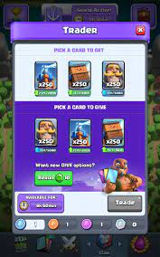

1. Trading Hall, platform to trade equipment with other players
   1. Players can designate another player to trade with, such as legendary items for another item, players designate their own “currency worth” with another player
   2. Preventions of clear unfair trading systems each player must put one item for trading slot
   3. 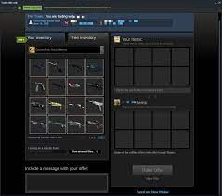
2. Auction Hall
   1. Set limit value limit for rare items sold to decrease scams occur in the auction systems (Rare item max price would set to the min price of an epic item)
   2. 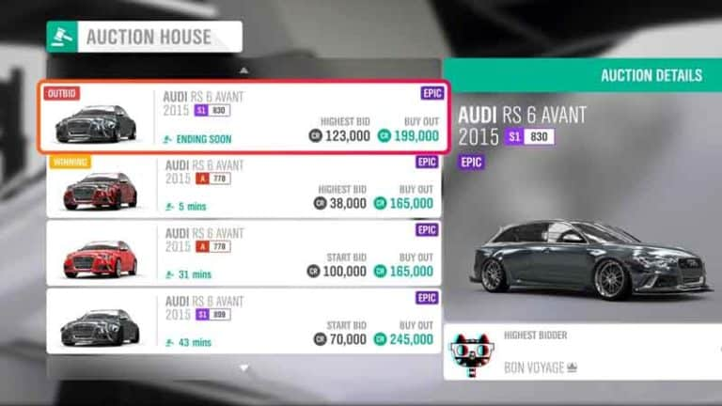

* Exploration

1. Ladder, Scaffold, Vines, can climb up and down for vertical access to areas, 2 way
2. Zipline, Can enter otherwise inaccessible areas, usually 1 way
3. Barricades/Fences/Windows, can vault over and access areas, 2 way

* Combat

1. Explosive barrels
   1. Boom
2. Stuff

* Others
  + Doors
    - Sides open when player is within 2m of door
  + Lights
    - Turns on when there is movement nearby, 10m radius

--------------------------------------------------------------------------------------------------------------------------------------------

Cosmetics and Rarity

* Cosmetics

1. Sold for ingame currency
2. Can change gender, and colors for most armors
3. Can buy premade skins
4. Can buy individual body parts cosmetics
5. Can buy gun skins
6. WIP

* Rarity

1. Base rarity ranking from easily found to hardest (Common , Rare , Epic , Exotic ,Event Exclusive)
2. Skins reference from each rarity (image from different games)

--------------------------------------------------------------------------------------------------------------------------------------------

Character Interactions

1. Characters of the game
   1. Main Storyline Characters
      1. General gives orders(missions)
         1. A veteran that commands rescue and gives operations to the special forces
      2. Scout
         1. Scans locations beforehand and also guides you through missions
         2. Unreliable as scout slacks off often
         3. Needing player to scan and explore areas themselves
      3. Pilot sends you to different map locations
         1. Cowardly
         2. Chose a simple job of ferrying people to places instead of fighting
      4. Vendor buys and sell items
         1. A rich merchant that found a business opportunity here, charges unfairly to earn more money
   2. Side Characters
      1. Interaction given there are not given with much options to reply but is more of side story
      2. Players should take notice of text they say as there will be hints to find the quest areas or the other details
      3. These messages are repeatable so that the player would not feel so lost or troubled when they are not able to clear a certain part of the quest, needing to explore the community to find more details
      4. Ie single or double text interaction insert image here of text.

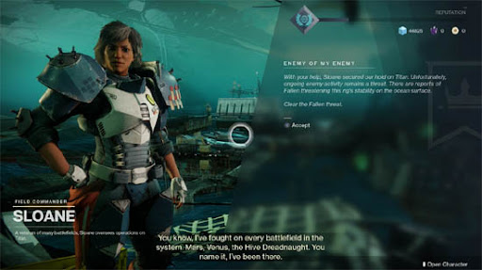

--------------------------------------------------------------------------------------------------------------------------------------------

Interactions(mechanics)

* Core

1. Movement(take from above)
2. Ranged Attacks aka shooting
3. Reloading
4. Looting

* Secondary

1. Maneuvers: Upon entering detection radius of preset “Climb zone”, Player can interact with object to “Vault”, “Climb”, this freezes all combat controls and moves player on preset path. allows for climbing/rappelling areas with ladders/scaffolds/vines, vaulting short barricades/fences, sliding, ziplines**(refer to Objects:Exploration)**
2. Melee Attacks, Heavy Attacks**(refer to Weapons & Attacks)**
3. Skills**(refer to skills)**
4. Consumables**(refer to Consumables)**
5. Hiding behind/inside environmental objects**(refer to Objects:Environmental)**

* Progressive

1. Gun Modding**(refer to Guns & Attachments:Attachments)**
2. Inventory**(refer to Inventory)**
3. Skill Tree
4. Boss Battles**(refer to Enemies:Bosses)**

* Narrative

1. Characters**(refer to Characters)**
2. Story
3. Context of the game

--------------------------------------------------------------------------------------------------------------------------------------------

Stuff

ADD Reference Images For everything. Slides need to be more visual. Infodump needs to be detailed for GDD fml

Map Reference image, shattered planet

Dauntless images



Portal knight

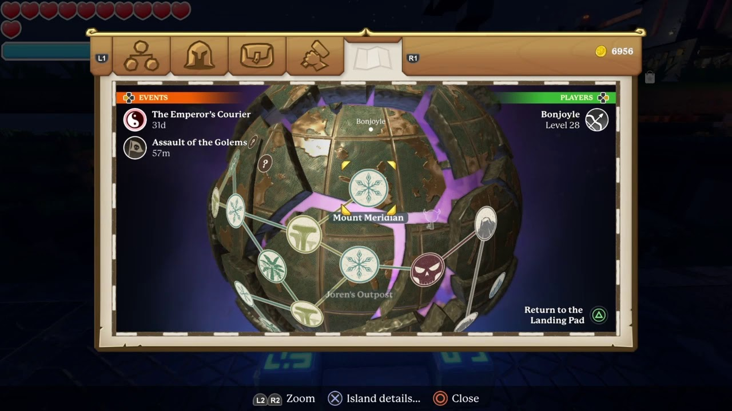

Inventory, grid slot, arrangement

Subnautica

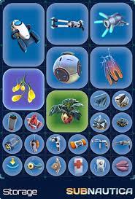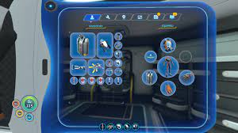

Unturned inventory

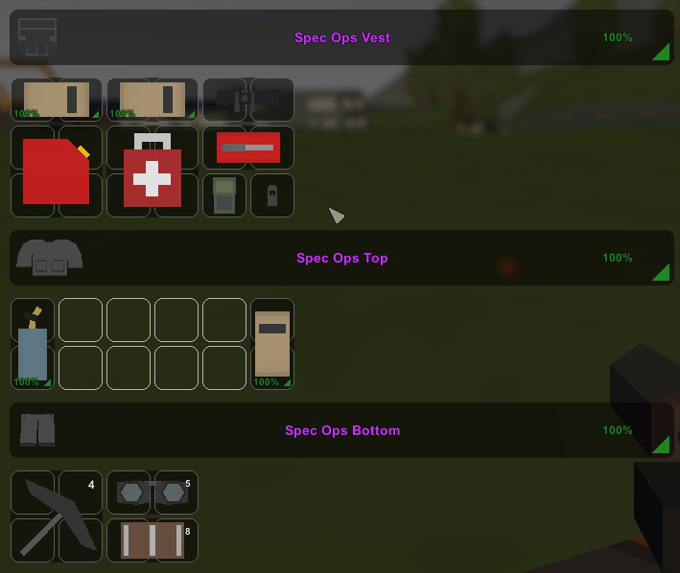

Skill trees reference

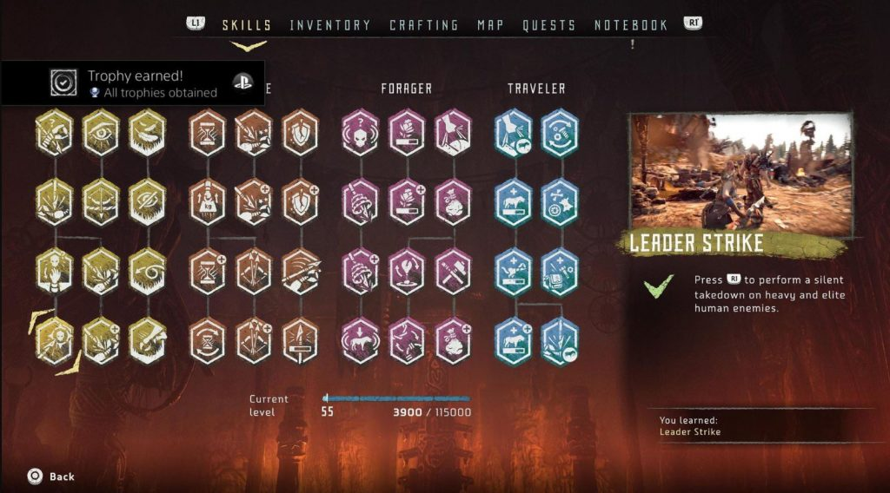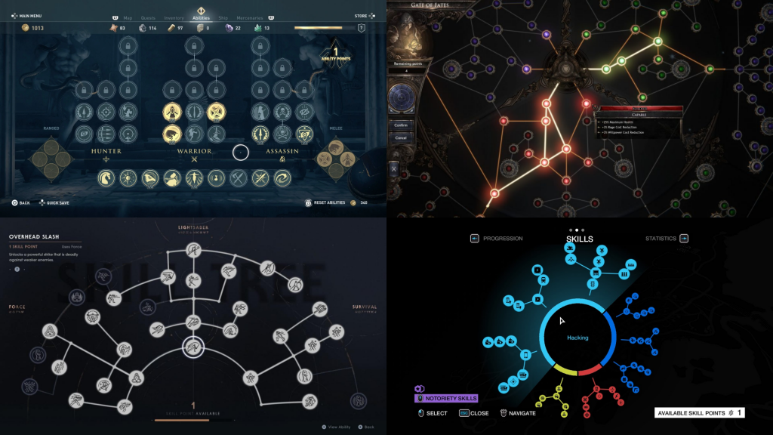

<https://www.google.com/url?sa=i&url=https%3A%2F%2Fgdkeys.com%2Fkeys-to-meaningful-skill-trees%2F&psig=AOvVaw3LOJEOaEpN7vWVvIe4Mc-4&ust=1641043397812000&source=images&cd=vfe&ved=0CAgQjRxqFwoTCLCJhpmRjvUCFQAAAAAdAAAAABAI>

<https://www.google.com/url?sa=i&url=https%3A%2F%2Fgdkeys.com%2Fkeys-to-meaningful-skill-trees%2F&psig=AOvVaw3LOJEOaEpN7vWVvIe4Mc-4&ust=1641043397812000&source=images&cd=vfe&ved=0CAgQjRxqFwoTCLCJhpmRjvUCFQAAAAAdAAAAABAD>

Gun modding reference

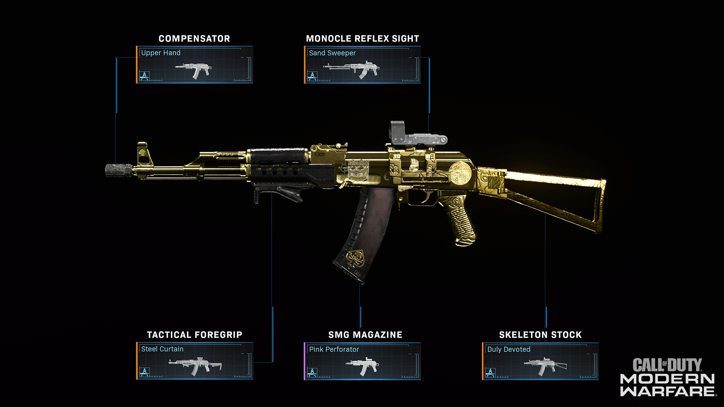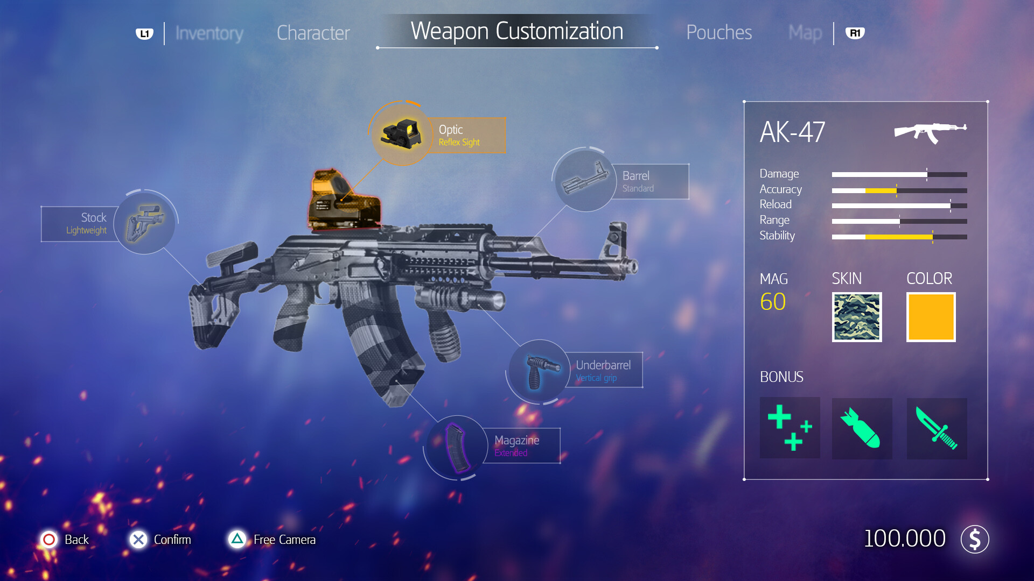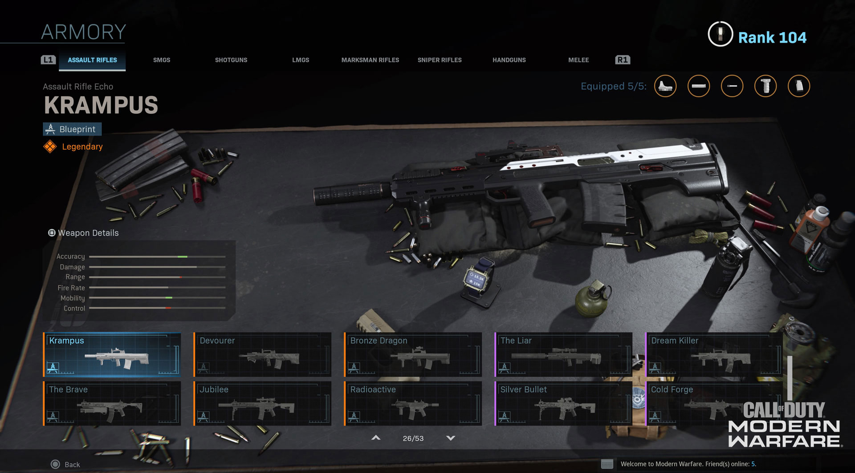

Weapon Models Reference

Pistols

Revolver: Glock 17:

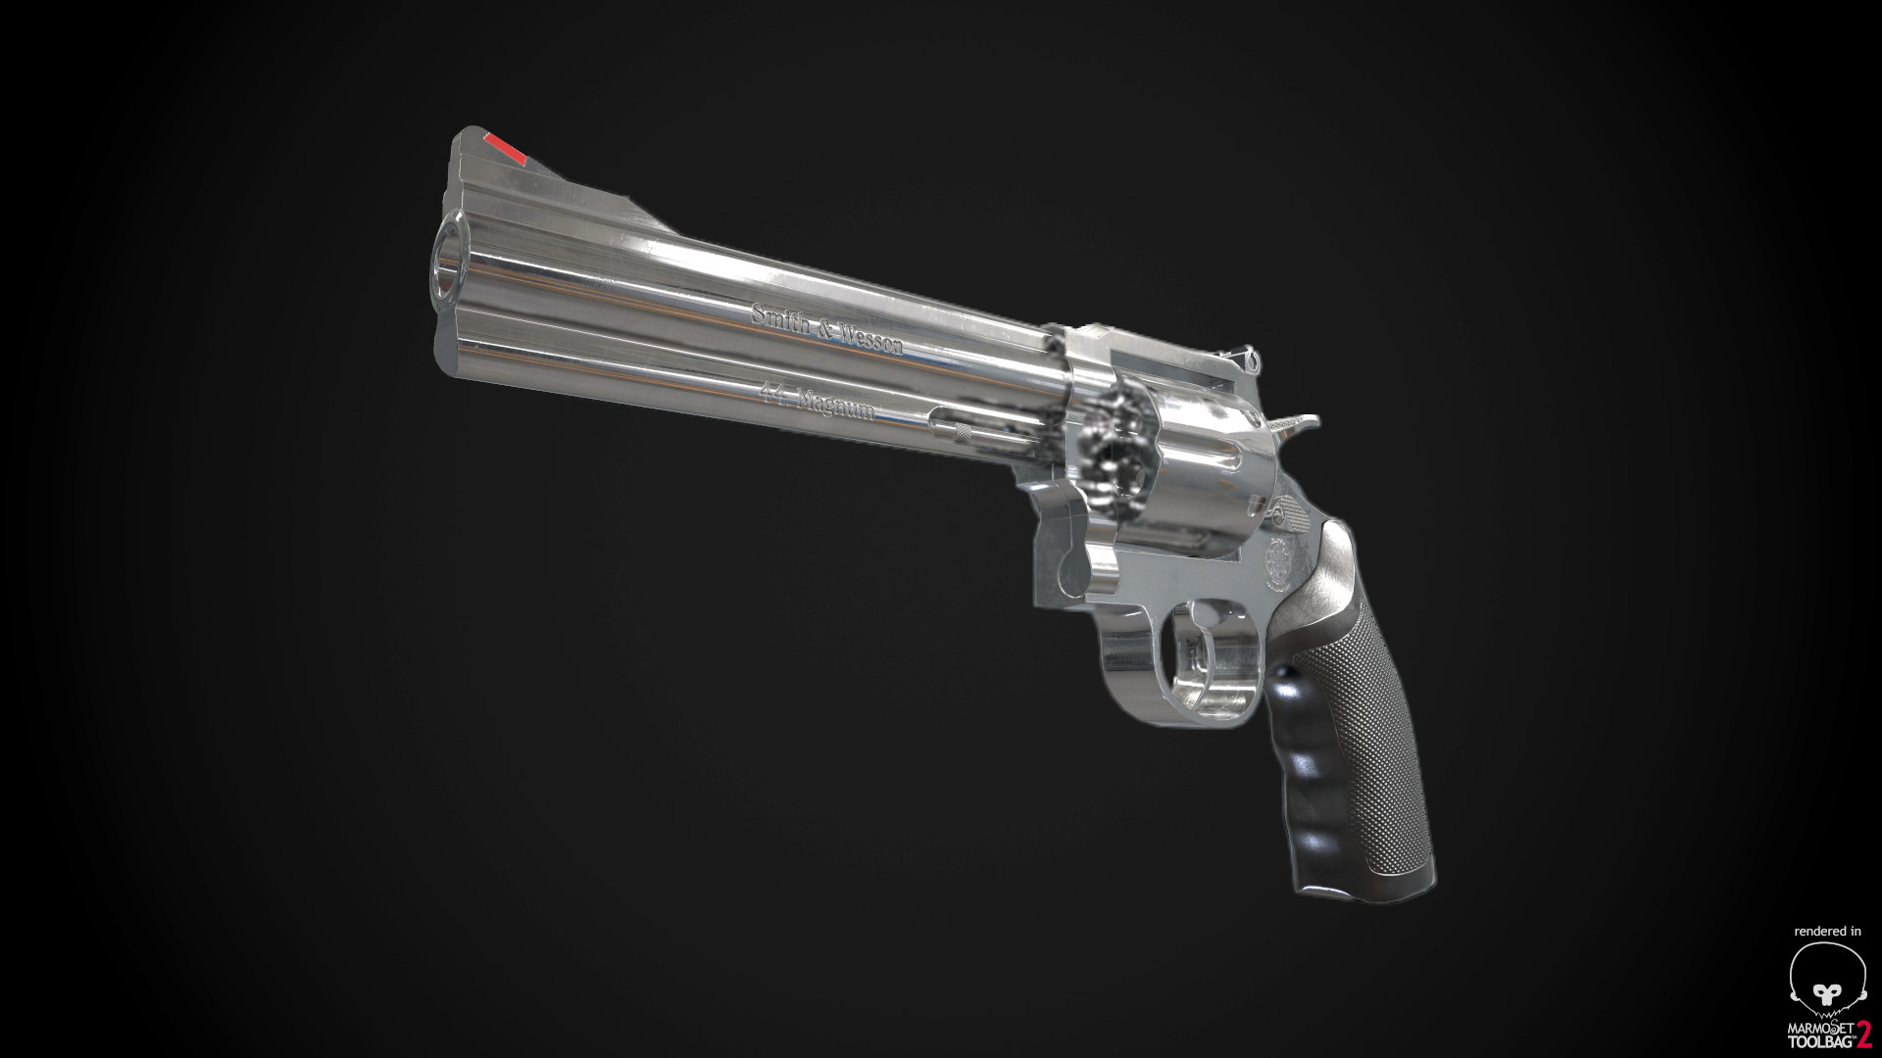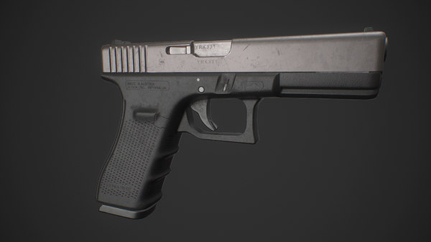

Deagle: FN-FiveSeven:

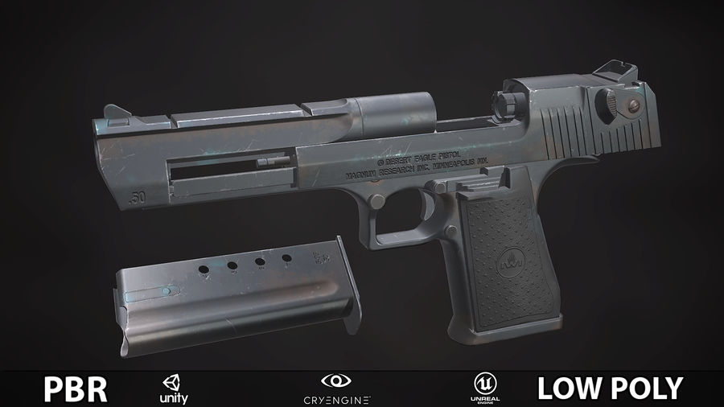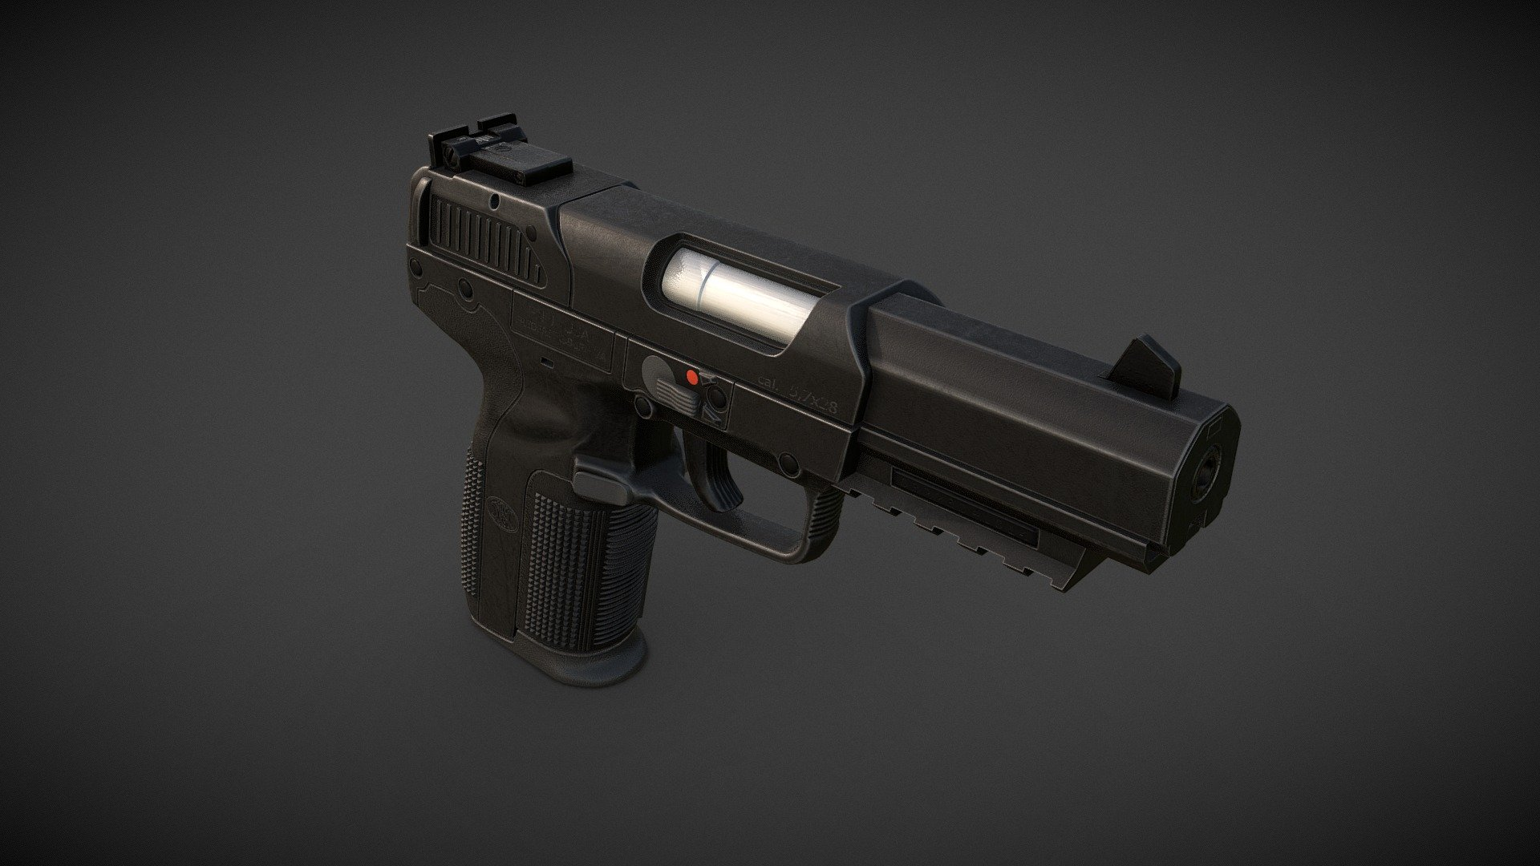

SMGs

UZI: Vector:

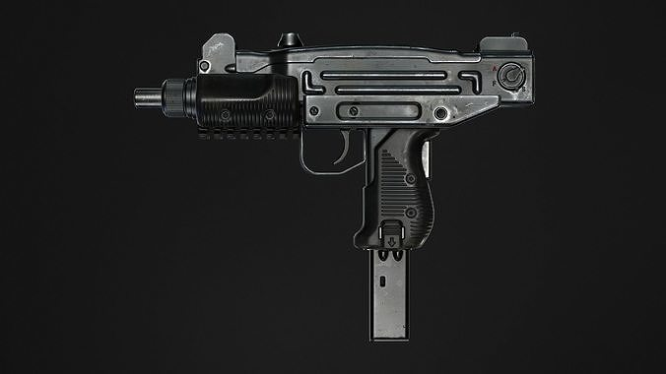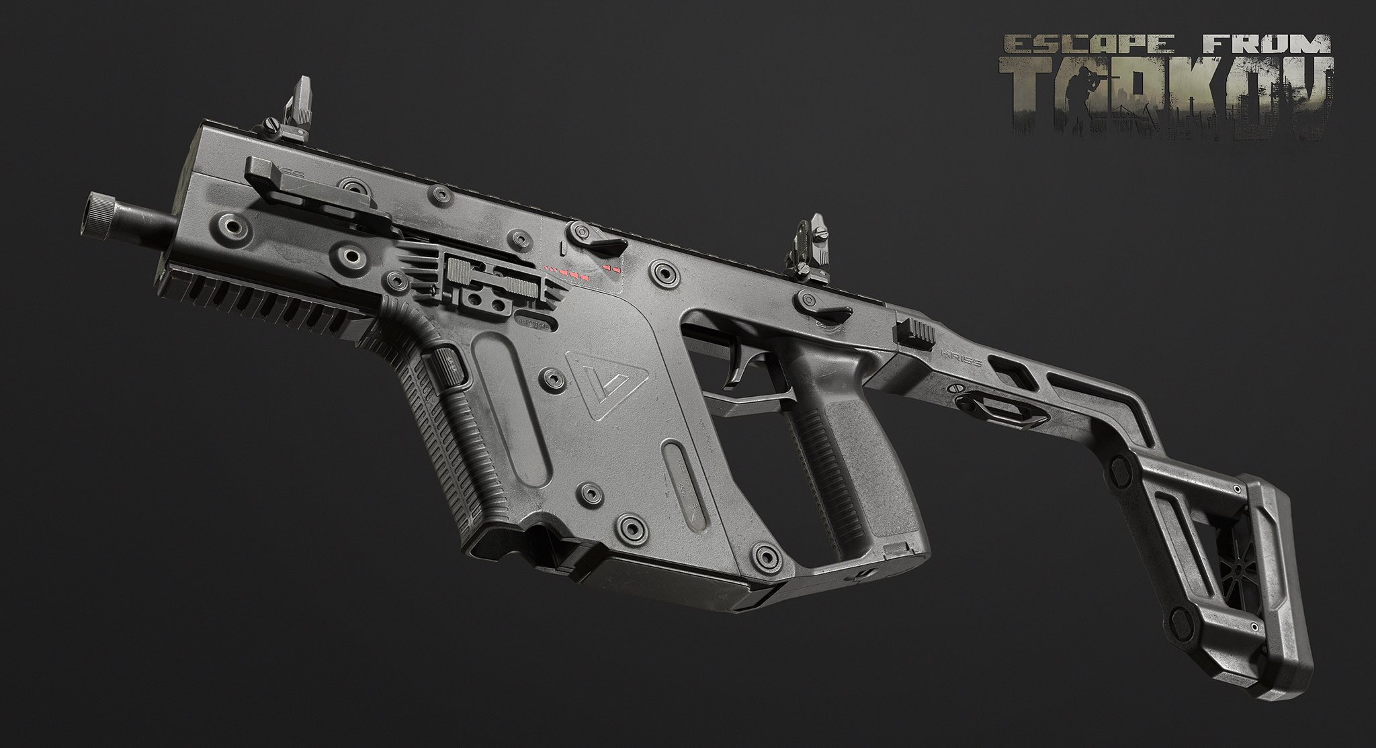

P90: MP5

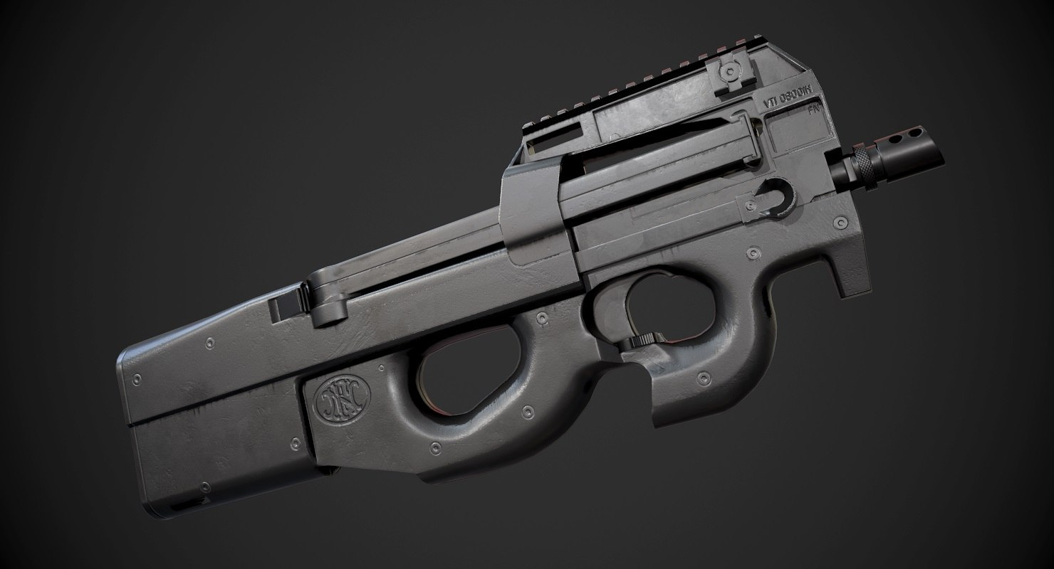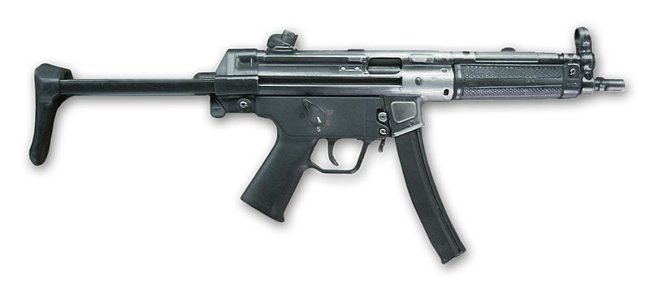

Grenade:

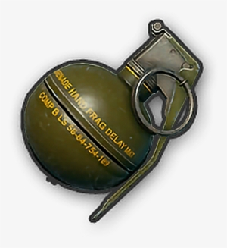

Status effects images

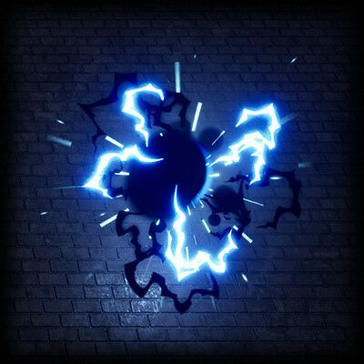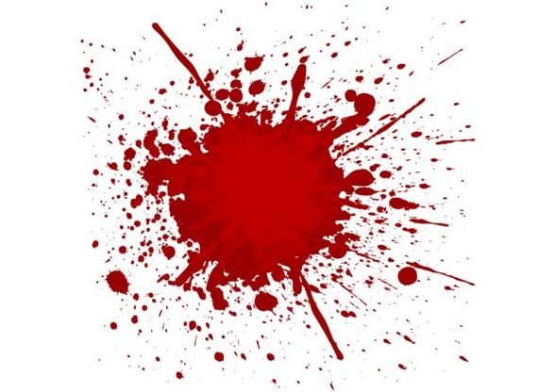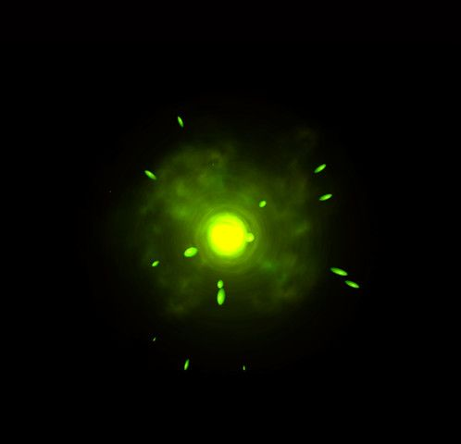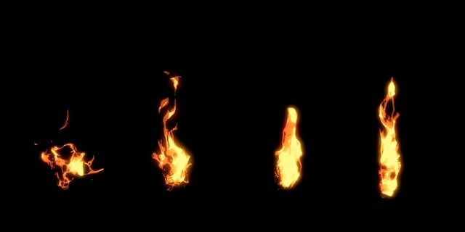

Melee weapons

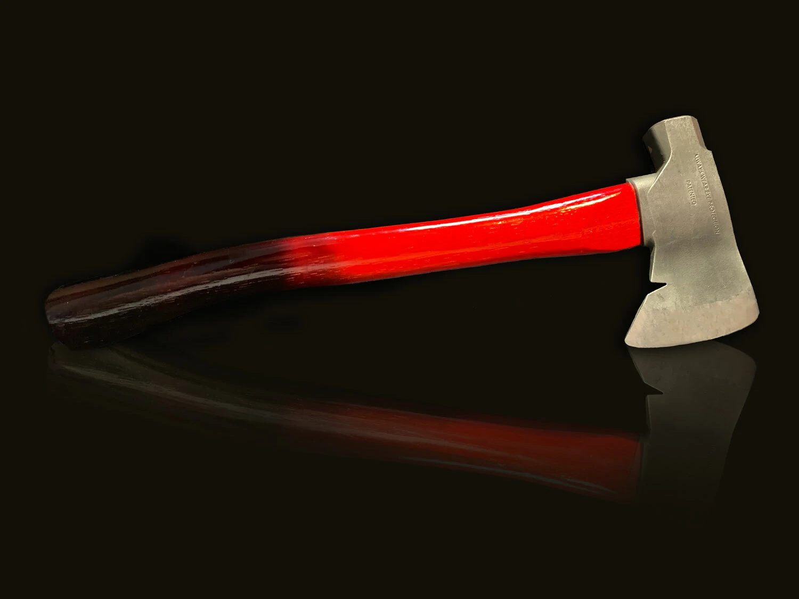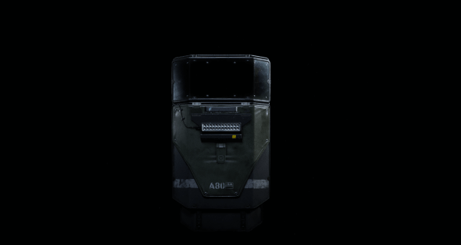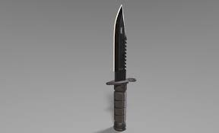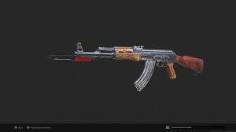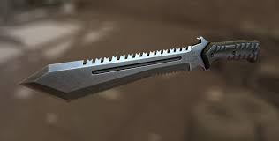

Notes to take from other teams:

Team 1:

-have pic not enough discription

-combat no details about programming about how things work

-How each thing work together

-1 breakdown for each component

Team 2:

-better visuals

-need more storyboarding for mechanics

-need more mechanics